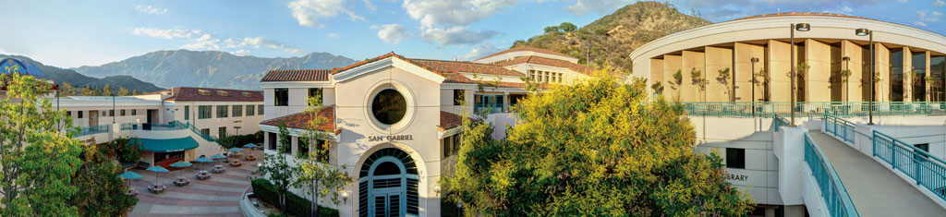

GLENDALE COMMUNITY COLLEGE DISTRICT

Annual Report of the
Measure GC
Citizens’ Bond Oversight Committee
2024-2025 FISCAL YEAR

Financial and Performance Audit as of June 30, 2025
Project Status Information as of June 30, 2025

T A B LE O F CONTE NTS
About the District 1
Introducing the Measure GC Citizens’ Bond Oversight Committee 4
- Committee Activities 5
Measure GC Projects Active in 2024-2025 6
Measure GC Capital Projects 10
Summary of Measure GC Audit
- Financial Statement Summary 11
- Internal Control Audit Summary 12
- Performance Audit Summary 12
- Acceptance of the Audit 12

ANNUAL REPORT OF THE
MEASURE GC
CITIZENS’ BOND OVERSIGHT COMMITTEE
GLENDALE C O M MU NIT Y CO LL EGE D IST RI CT
2024 - 2025 FISCAL YEAR
The District is pleased to deliver the Measure GC Citizens’ Bond Oversight Committee Annual Report to the Glendale Community. This Annual Report includes an overview of the History, Region, and District Service Area as well as an explanation of the Measure GC Citizens’ Bond Oversight Committee, highlights of the Committee activities, Measure GC funding and capital projects, bond projects active in 2024-2025, and a summary of the bond performance and financial audits.
HISTORY AND REGION
A B OUT T HE DIST R I CT
Glendale Community College was founded in 1927 as Glendale Junior College to serve the needs of the people in the Glendale Union High School District which included La Crescenta, Glendale, and Tujunga. From 1927 to 1929, classed were conducted in the buildings of Glendale Union High School at Broadway and Verdugo in the City of Glendale. In 1929 the Junior College moved to the Harvard School plant of the Glendale Union High School District where it remained until 1937. In this year a new plant, part of the present one, was completed and occupied. The year before, in 1936, the Glendale Junior College District was dissolved as such and became a part of the new Glendale Unified School District. The name of the school was changed to Glendale College in 1944. On July 1,1970 Glendale College became a part of the Glendale Junior College District. On April 20,1971 the Board of Education adopted a resolution changing the District’s name to Glendale Community College District. On November 3,1980, Glendale voters approved a measure to establish separate Boards for the College District and the High School District. In April 1981, the new members were added to the College District Board. The separation resulted in the creation of a Board of Trustees solely responsible for the governance of the Glendale Community College District.
In 1936, 25 acres were acquired for the present site of the college. It is beautifully located on the slopes of the San Rafael Mountains overlooking the valleys in the Glendale area. Today, the College has 27 permanent buildings over 100 acres. These facilities include The College’s original Verdugo campus, and its Garfield and Montrose campuses.

The District is located in Los Angeles County (the “County”) and its boundaries include the City of Glendale, small portions of the City of La Cañada-Flintridge and unincorporated communities in Los Angeles County. The District operates the Glendale Community College (the “College”), which includes three local sites: (i) the Verdugo Campus, which provides the majority of credit programs leading to degree completion, career certificates and transfer to four-year universities, (ii) the Garfield Campus, which provides noncredit programs, including ESL, citizenship, and career programs, and (iii) the Montrose Campus, which runs an Educational Training Program that is funded by the State, County and businesses to provide specialized training to meet business and industry needs. The College also operates a field research center, in Bahia de Los Angeles, on the Baja peninsula that serves students in Biology and other related disciplines. The College is fully accredited by the Accrediting Commission for Community and Junior Colleges.
DISTRICT SERVICE AREA
I NT RODUCI NG T HE
MEASURE GC CIT IZ ENS ’ BO ND O VER SIG HT C O M MITTEE

California Proposition 39, known as the School Facilities Local Vote Act, passed November 7, 2000. Prop 39 reduced the threshold needed to pass local California school and college district bond issues from a two-thirds supermajority vote to a 55 percent vote. California Education Code Section 15278 establishes requirements for an Independent Citizens’ Bond Oversight Committee to be established when bond measures are passed under Prop 39. This committee, comprised of local residents, has the main charge of informing the public of how their bond dollars are spent and ensuring expenses are in line with the approved ballot language. The California Education Code specifies requirements for at least seven Committee members to serve for a term of two years (and no more than three consecutive terms). No employee, official, vendor, contractor, or consultant of the District shall be appointed to the Committee. Members shall serve without compensation.

The Committee shall be comprised of at least:
  - one member active in a business organization representing the business community located within the district;
  - one member active in a senior citizens’ organization;
  - one member active in a bona fide taxpayer’s organization;
  - one student, both currently enrolled in the District and active in a campus group (the student may serve up to six months after his or her graduation);
  - one member active in the support and organization of a district (such as a member of the advisory community college committee or the GCC Foundation);
  - and two members of the community at-large.

The Measure GC Citizens’ Bond Oversight Committee:
- Actively reviews and reports on the expenditure of taxpayers’ money for construction to ensure the bond funds are spent in accordance with the provisions of the Bond and is accountable to the public.
The purpose of the Measure GC Citizens’ Bond Oversight Committee is to provide oversight for the bond program, transparency, and communication with the public about bond expenditures. It does not have the authority to choose, prioritize, or direct bond projects. During the 2024-2025 fiscal year, the Committee was comprised of seven appointed members, including a chairperson. District staff provided technical and administrative assistance to the Committee.

Position | Name
Business Organization | Mr. Zanku Armenian (Chair)
Community at Large | Ms. Tina Parsegian (Vice-Chair)
Community at Large | Ms. Monica Campagna
Senior Citizen Organization | Ms. Roberta Hagopian
Community at Large | Mr. Daniel Kim
Taxpayer Organization | Mr. Harry Leon
Associated Student Government Representative | Mr. Nathan Andriassian

COMMITTEE ACTIVITIES: 2024 - 2025

The Committee convened and participated in several key activities central to their main charge, including reviewing program expenditures and annual audits and reviewing the Annual Report. The Measure GC Citizens’ Bond Oversight Committee met quarterly during the 2024-2025 fiscal year. Proceedings of Measure GC Citizens’ Bond Oversight Committee meetings included:

- Review and Acceptance of Financial and Performance Audits
- Review Life-to-Date Expenditures Reports
- Review and Affirm District’s Compliance with Requirements
- Review Committee Bylaws
- Review Roles and Responsibilities
- Review Committee Membership
- Review Project Status Reports

MEASURE GC FUNDING AND CAPITAL PROJECTS

At the election conducted on November 8, 2016, the voters authorized up to $325,000,000 of the Glendale Community College District's general obligation bonds. Measure GC passed with 73.74 percent voter approval. These funds have enabled the District to continue to upgrade educational facilities, add classrooms and instructional support space at the Verdugo campus, Garfield campus, and the Professional Development Center (PDC) in Montrose.

- The first issuance occurred in March 2017 in the amount of $122,000,000.
- The second issuance occurred in June 2020 in the amount of $202,999,762.65.

B O ND P ROJE CT S A CT IVE I N 2024 - 2025
The projects summarized in the table below were begun, in process, or completed in the 2024-2025 fiscal year using money from Measure GC General Obligation Bonds.

Project | 2024-2025  Measure GC Expenditures | Measure GC LTD Expenditures | Total Projected Project Cost as of 06/30/25
Buena Vista – Science Building | $18,622,364 | $108,686,183 | $127,308,547
PE Expansion and Seismic Retrofitting | $575,113 | $36,543,347 | $37,118,460
Central Plant | $207,275 | $7,844,957 | $8,052,232
Infrastructure | $152,385 | $5,427,323 | $5,579,708
San Gabriel 2nd Floor Renovation-Math | $3,304,490 | $728,228 | $4,032,718
Camino Real | $211,314 | $589,514 | $800,828
IBCC – Performing/Conference Center | $202,294 | $355,697 | $557,991
Facility Strategic Plan | $5,005 | $356,237 | $351,242
Garfield Expansion | $107,650 | $18,294 | $125,945
Total 2024-25 Expenditures and LTD | $24,017,966 | $159,909,706 | $183,927,672

Measure GC Projects Active in 2024-2025:

Buena Vista Phase I (Building) & Phase II (Parking) (FKA New Science Building and Ancillary)

Phase I: Building Structure​
- 100% complete ​
- Construction Start – March 2021 ​
- Substantial completion & Occupancy Spring 2024 (Feb 21, 2024)​

Phase II: Demolition, Accessible Parking, ADA POT ​
- 100% complete ​
- Construction Start – March 2024​
- Final Striping scheduled for Nov 22, 2024​
- Substantial completion & use Spring 2025 (Feb 04, 2025)​

Key Milestone Completion Dates
- June 13, 2024 Phase I - Ribbon Cutting Celebration & Building Opening​
- Jan 6, 2025 Phase II -Circle Drive & Campus Way Road resurfacing complete​

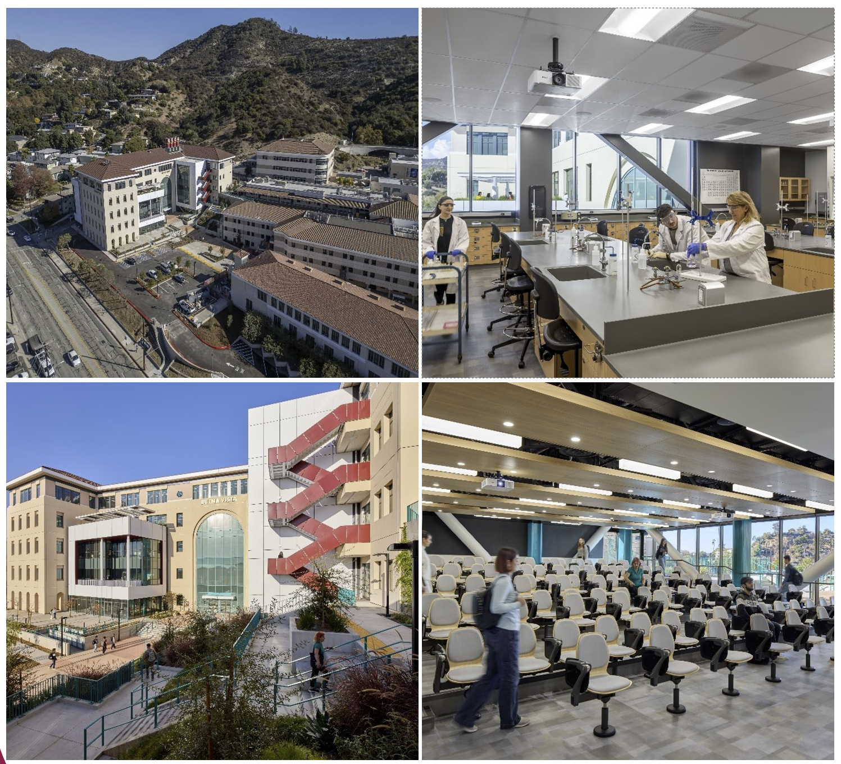

Camino Real Renovation

The Camino Real Renovation project (17,660 sf), spanning two floors in the Existing Building, will be renovated as the new home for Dreamscape Learn (DSL) Virtual Reality (VR), Makerspace, e-Gaming and Student Inclusion Spaces.

Key Milestone Completion Dates:
- Feb 27, 2025 DSA Approval
- April 14, 2025 Notice to Proceed (NTP)
- April 2026 (Spring) Beneficial Occupancy
- April 2026 Tentative Ribbon Cutting Event

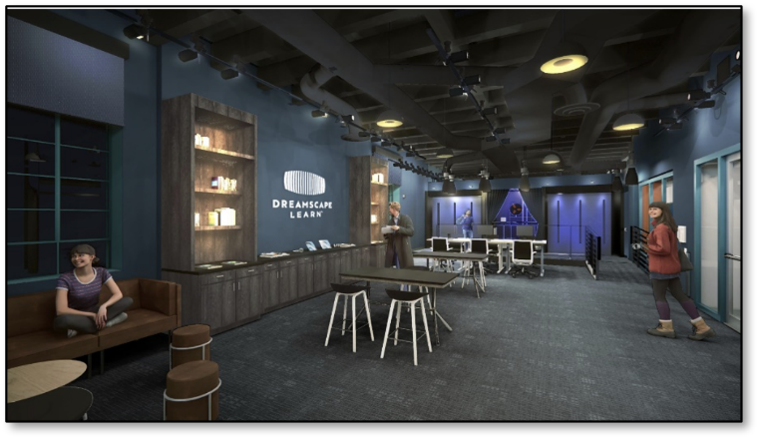
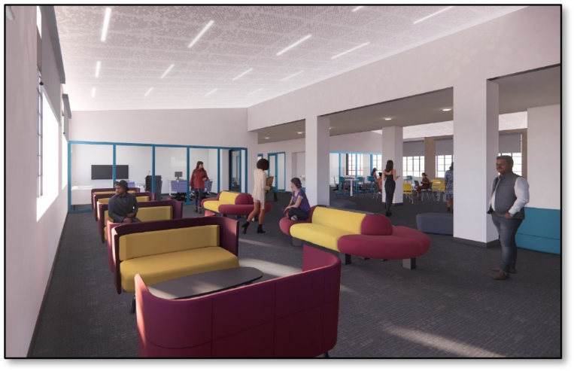
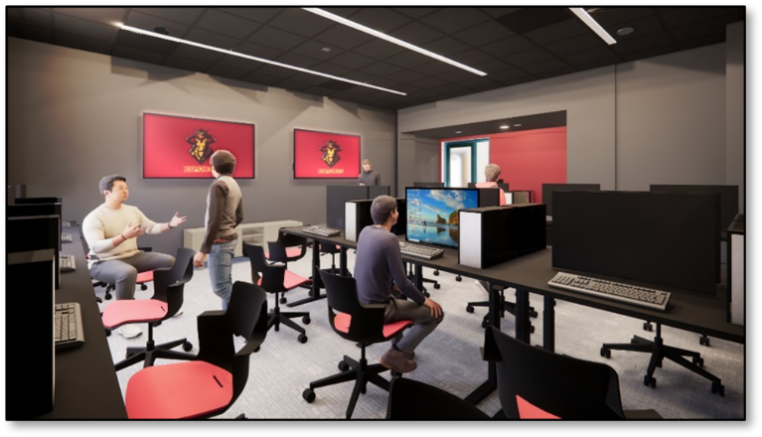

San Gabriel L2 - Math Description:
- Renovate 2nd floor of San Gabriel Building for Math into state-of-the-art math classrooms and labs, including Math Discovery Center

Key Milestone Completion Dates
- Nov 18, 2024 Substantial Completion Date
- Jan 29, 2025 Existing Furniture Move-in
- Jan 31, 2025 Sliding Glass Partition Installation
- Feb 19, 2025 BKM Furniture Delivery
- Feb 28, 2025 Final Completion; Phased Move-in
- May 3, 2025 Space was showcased in GCC Open House

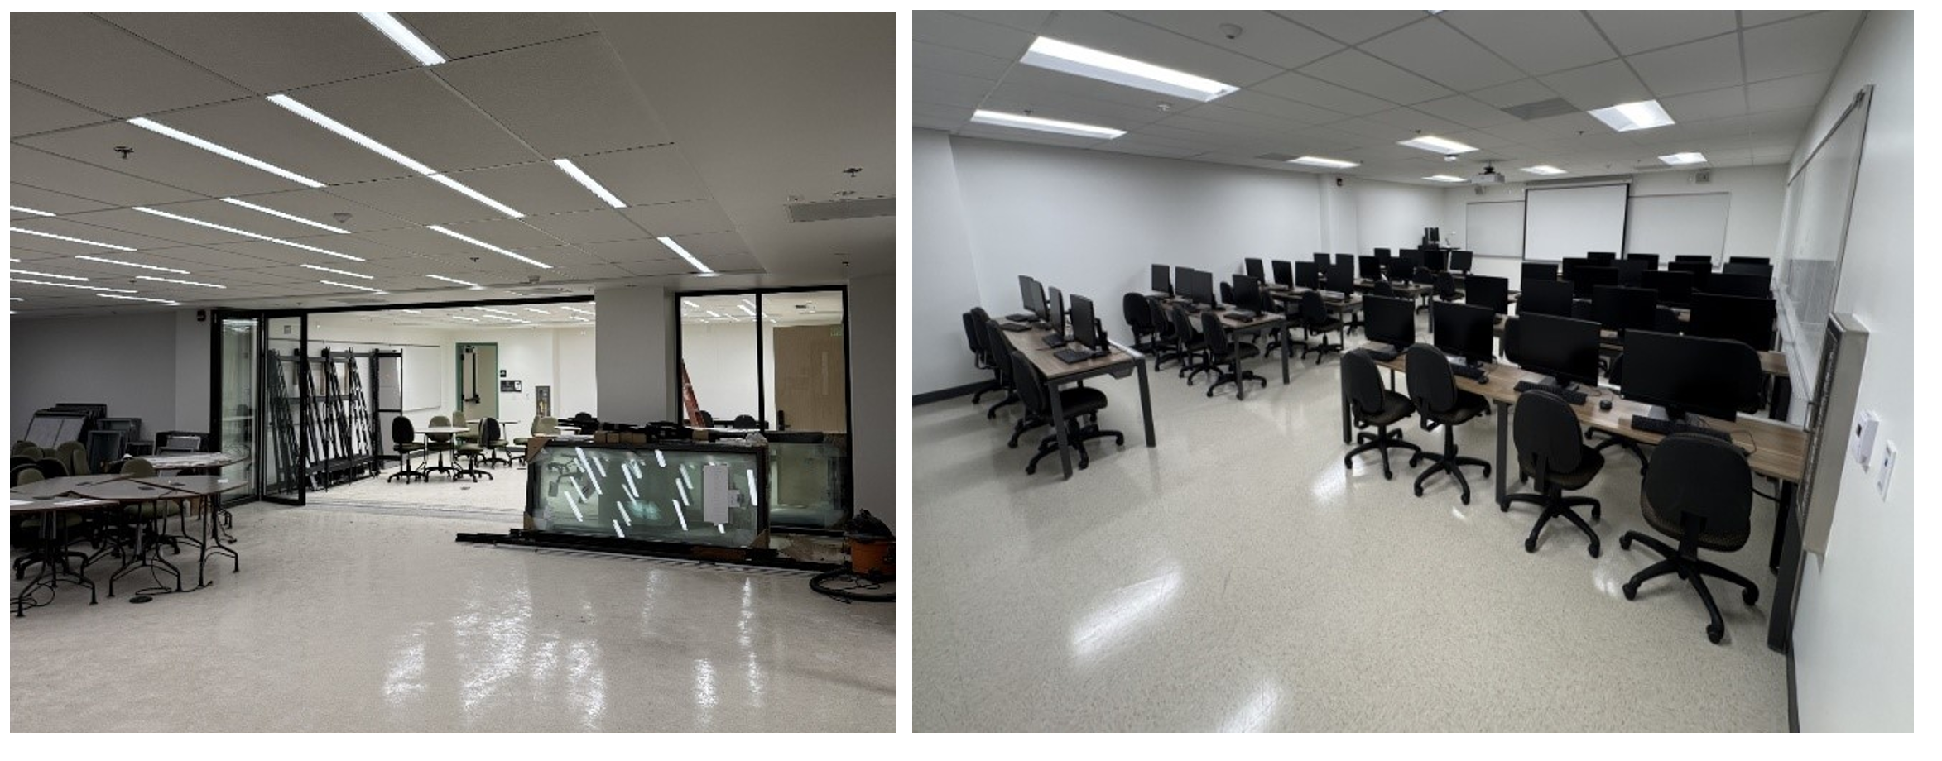

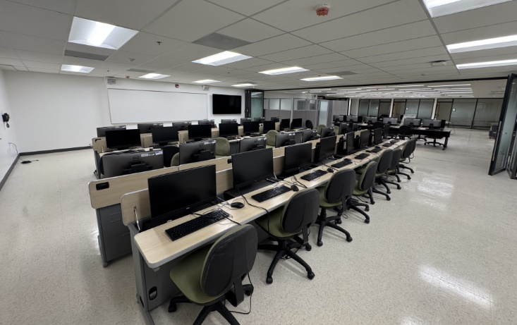
Facility Strategic Plan
- 19Six Architects programming consultants for Glendale Community College’s 2025-2035 Facilities Strategic Plan, presented to the Board of Trustees on July 26, 2024.
- Final Facilities Strategic Plan Board of Trustees (BOT) Approved on Nov 19, 2024.

MEASURE GC CAPITAL PROJECTS COMPLETED AS OF 6/30/2025

1 | Admin Window Replacement
2 | Administration Building for Human Resources
3 | Central Plant #1 Expansion
4 | Buena Vista Phase I (Building) (FKA New Science Building and Ancillary Projects)
5 | Buena Vista Building-Phase II
6 | Classroom Lab Renovation Projects
7 | EnTech - Entertainment Technology
8 | Facilities Strategic Plan (FSP)
9 | Fire Academy Project
10 | Garfield Mariposa Renovations
11 | Garfield Property Acquisition, Parking & Landscape
12 | HR RENO-FF&E
13 | Infrastructure
14 | Kinesiology and Vaquero Athletic Complex/ PE Student Locker & Shower  (Expansion and Seismic Retrofitting)
15 | Minor Capital Projects
16 | Montrose Campus
17 | Safety & Security
18 | San Gabriel First Floor-DSPS Office Space
19 | San Gabriel Second Floor Renovation for Math Department
20 | San Rafael Renovations Second Floor
21 | Sierra Vista Closeout
22 | Technology
23 | Welding Lab Alteration-Tongva (Aviation Art) Building

S UM MARY OF ME AS URE GC AUDIT
In accordance with Proposition 39, each year that the District has unexpended bond proceeds, it engages an independent CPA firm to perform Financial and Performance audits of the Measure GC General Obligation Bond Fund (the Fund”). This year’s General Obligation Bond Financial and Performance audits were performed by CWDL. The auditors issued three reports which are discussed in greater detail below.
FINANCIAL STATEMENT SUMMARY:

CWDL performed an audit of the Fund’s financial statements for the year ended June 30, 2025. The audit was performed in accordance with both Generally Accepted Auditing Standards and Government Auditing Standards. The audit opinion of CWDL states that the financial statements present fairly, in all material respects, the financial position of the Measure GC General Obligation Bond Construction Fund of the District as of June 30, 2025, and the changes in financial position for the year ended in accordance with the accounting principles generally accepted in the United States of America.

The following is a summary of the changes in the Fund Balance for the year ended June 30, 2025.

GLENDALE COMMUNITY COLLEGE DISTRICT
MEASURE GC GENERAL OBLIGATION BOND CONSTRUCTION FUND STATEMENT OF REVENUES, EXPENDITURES, AND CHANGES IN FUND BALANCE FOR THE YEAR ENDED JUNE 30, 2025

REVENUES  Investment income |  | $ 6,244,798
Total Revenues |  | $ 6,244,798
EXPENDITURES  Salaries and employee benefits |  | 447,850
Supplies and materials |  | 34,260
Other operating expenses and services |  | 472,304
Capital outlay |  | 24,039,316
Total Expenditures |  | 24,993,730
Net Change in Restricted Fund Balance |  | (18,748,93)
Restricted Fund Balance, July 1, 2024 |  | 36,871,224
Restricted Fund Balance, June 30, 2025 $18,122,292

INTERNAL CONTROL AUDIT SUMMARY:
CWDL issued a report on Internal Control over Financial Reporting and on Compliance and Other Matters Based on the audit of the Fund’s financial statements for the year ended June 30, 2025. Internal controls are accounting procedures designed to detect and correct misstatements on a timely basis.

- During the audit CWDL did not identify any internal control deficiencies that would prevent District management or employees to perform such procedures.
- There were no findings of noncompliance or other matters that are required to be reported under Government Auditing Standards.
- There were no audit adjustments.
PERFORMANCE AUDIT SUMMARY:

CWDL conducted a performance audit in accordance with generally accepted audit standards of the Comptroller General of the United States. They tested 87.01% the total expenditures incurred and reviewed the associated purchase orders, approved invoices, bid documentation, contracts, and budgets. The results of such tests indicated that the District expended Measure GC General Obligation Bond Construction Fund only for the specific projects approved by the voters, in accordance with Proposition 39 and outlined in Section 1 (b) (3) (C) of Article XIIIA of the California Constitution.
- The District has properly accounted for the Fund’s expenditures. Supporting documents for expenditures were aligned with the voter-approved bond projects list.
- The District appropriately charged employees’ salary and benefits to the Fund for employees that provided direct oversight to Measure GC projects. Supporting documents for expenditures were not used for salaries of school administrators or other operating expenses of the District.
ACCEPTANCE OF THE AUDIT:

On February 4, 2026, representatives of CWDL met with the Measure GC Citizens’ Bond Oversight Committee to present the audit reports. After that presentation the Measure GC Citizens’ Bond Oversight Committee approved accepting the audit reports.

