BIOL 50 Natural History Museum Internship
Offered in Fall & Spring 16-week semester and
5-week Summer/Winter Intersession

Students work as interns at the Natural History Museum of Los Angeles County (NHMLA), which holds some of North America's largest specimen collections. Biol 50 interns at NHMLA learn techniques for collections improvement and management (e.g., specimen digitization, labeling, organization) and conduct specimen-based research projects within one of 13 departments (e.g., Malacology, Dinosaur Institute, Ornithology, Ichthyology). Research projects can include comparative anatomy methods, using technologies such as CT scanning or electron microscopy (SEM), and/or molecular phylogenetic approaches, from DNA extraction to sequence analysis, to identify new species and resolve evolutionary relationships. Students are invited to participate in museum outreach events (NHMLA’s Haunted Museum, NatureFest, etc.), contribute to papers for publication as coauthors, and present their research results at local scientific conferences.
Contact: Dr. Jann Vendetti, jvendetti@nhm.org
or Dr. Javier Gago, BV 231, ext. 5369, fgago@glendale.edu
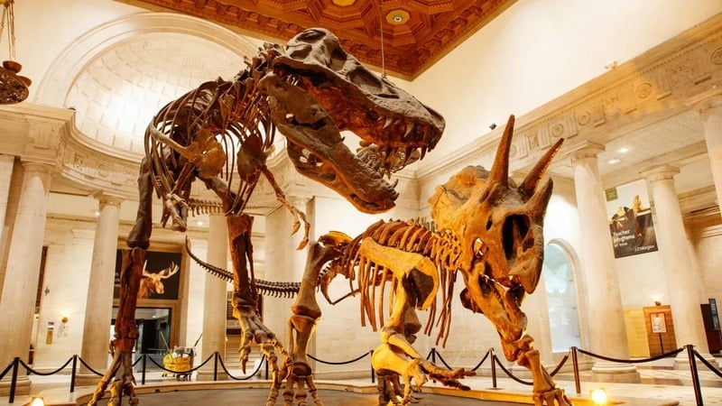


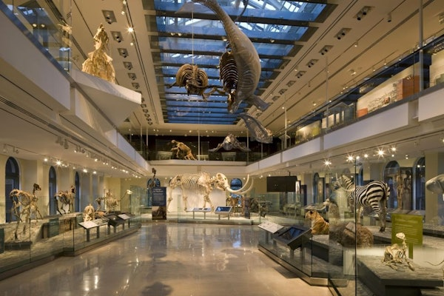
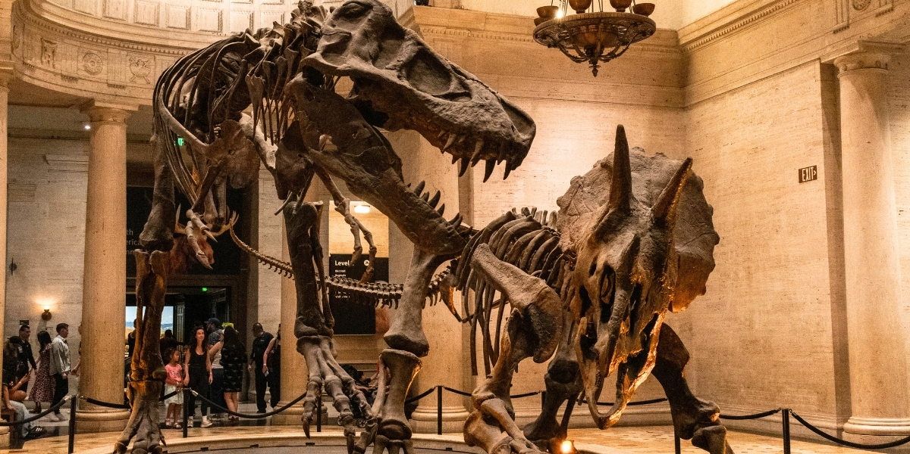
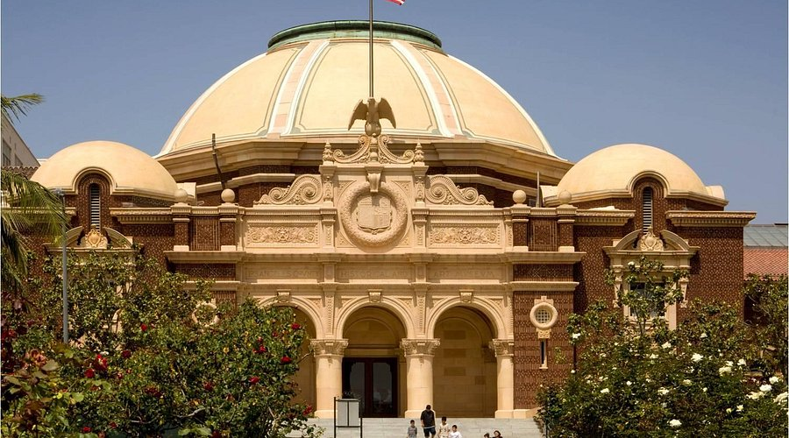

GCC Student Research Projects at NHMLA:
- First record of Lepidopus from the Miocene of the Monterey Formation (Lompoc, California).
- Development of fin spines in trichiuroid genera (Scombroidei).
- A phylogenetic analysis of the trichiuroid genera (Scombroidei).
- Description of a new species of lanternfish (Symbolophorus reversus).
- A study of the pharyngeal teeth of the Pacific viperfish (Chauliodus macouni T.H. Bean, 1890) and a comparison to other genera of barbeled dragonfishes (Stomiidae).
- Comparative analysis of the pelvic-fin spines in larvae and adult snake mackerels (Gempylidae) and cutlassfishes (Trichiuridae).
- Frogfish Osteology: Pectoral Girdle.
- Convergent evolution of icefishes.
- Variation in otolith shape across orders of ray-finned fishes (Actinopterygii).
- Study of the circumorbital series: morphological variation in the infraorbital series of fishes.
- A comparative analysis of photophore density between the two bioluminescent shark families: the kitefin sharks (Dalatiidae) and the lantern sharks (Etmopteridae).
- Correlation between the aphakic aperture length and ocean depth in the grenadier and morid fishes (Gadiformes).
- Analysis of body shape in stingrays (Myliobatiformes) and chemical composition of their stingers.
- A closer look at the possible synonymy of the ghost scabbardfish, Lepidopus manis (Scombroidei, Trichiuridae).
- Placoid scales and teeth morphology of three independent taxa of catsharks (Scyliorhinidae).
- Exploring the endangered desert pupfish (Cyprinodon nevadensis calidae, C. n. amargosae, C. salinus, and C. radiosus) through a morphometric analysis.
- Comparative morphology of fish otoliths.
- Morphology and evolution of venomous fishes.
- Does jaw length in teleosts increase with ocean depth?
- Does eye diameter in teleosts vary with depth?
- Evolutionary loss of scales in the snake mackerels (Gempylidae) and cutlassfishes (Trichiuridae).
- Apomorphy-based identification of Cretaceous marine turtles from the Niobrara Chalk Formation
- Exploratory studies of polyplacophoran eyes
- Analysis of Amphinomidae (Fireworms) chaetae using SEM and EDS.
- Testing methods of DNA extraction in scuttle flies (Phoridae).
- Molecular phylogeny and SEM of Euwallacea sp., the polyphagous shot hole borer beetle.
- Investigating shell surface microstructure of the Kellet’s Whelk (Kelletia kelleteii) and its relation to epibiont growth.
- Vertigo snails and other microgastropods of Southern California.
- Identification, anatomy, and phylogeny of a Rauisuchid Archosaur ilium.
- Confirming the identification of the Mosasaur Plotosaurus bennisoni from the Moreno Formation of California.
- Elemental and fluorescence analyses of marine gastropod shells.
- Urban biodiversity of Gastropoda in Los Angeles: Investigating morphological diversity of jaws and radulae.
- Radular morphology of cephalopods (Coleoidea) using Scanning Electron Microscopy (SEM).
- Phylogeographic analysis of the stubby squid (Rossia pacifica) using the CO1 barcoding gene.
- Identification of a Late Jurassic dentary of a sphenodont reptile (Opisthisa sp.) from the Fruita Paleontological Research Natural Area (Colorado).
- DNA isolation and amplification from shells of multiple species of Helminthoglypta (Southern California shoulderband snail).
- Morphological and phylogenetic investigation of the pustulose wart slug (Phyllidiella pustulosa).
- Anomalous marine mollusks from the Salton Sea.
- Genetic biodiversity of terrestrial snails and slugs of Southern California.
- SEM investigation of the carrier shell (Xenophora) microstructure and points of attachment.
- Radular morphology of the solar-powered sea slug (Elysia diomedea) using scanning electron microscopy.
- Comparative analysis and identification of the red-tipped sea goddess (Doriprismatica sedna) by scanning electron microscopy of the radula and the CO1 gene.
- Gastropod shell formation.
- A comparative analysis of the preservation quality of insect fossils from the Eocene Green River and Oligocene Rott Formations.
- Understanding genetic connectivity in Taylor’s sea share, Phyllaplysia taylori.
- DNA Barcoding of understudied California sea slugs: Armina californica and Tylodina fugina.
- A case study in the extended specimen: The integration of White Abalone and diatom records at the Natural History Museum of Los Angeles County.
- Identifying an introduced leatherleaf slug species from The Huntington Botanical Gardens: An integrative taxonomic approach.
- Multiple introductions of the Spanish milk snail, Otala lactea, in Southern California.
- The northern range limit of the Eastern Pacific marine gastropod Tegula eiseni is informed by recent iNaturalist records.
- Diversity in two Deroceras land slug species in Southern California.
- Origin and pervasiveness of the pestiferous land snail Theba pisana (Gastropoda: Helicinidae) in Southern California.
- Integrative taxonomy of the talus snails, genus Sonorella, desert snails of the American Southwest.
- Integrative taxonomy of banana slugs, genus Ariolimax.

Research Papers in Preparation or Published with GCC Student Co-Authors (in bold):
- Gago, F. J., E. R. Burnett, and J. D. Stewart. In preparation. New species of fossil scabbardfish, Lepidopus motereyensis sp. nov. (Scombroidei, Trichiuridae), from the Miocene Monterey Formation of California.
- Gago, F. J. and R. C. Ricord. 2005. Symbolophorus reversus: a new species of lanternfish from the Eastern Pacific (Myctophiformes: Myctophidae). Copeia 2005(1): 138-145.
- Vendetti, J.E., Casillas, J., Castro, A., and Sala, M. In preparation. The biogeographic range of the Eastern Pacific marine gastropod Tegula eiseni in California is extended by iNaturalist records. [To be submitted to PLOS ONE].
- Huguet Tuck, K., Welch, J., Garcia, J., and Vendetti, J. In preparation. An introduced leatherleaf slug species from The Huntington Botanical Gardens: An integrative taxonomic approach. [To be submitted to American Malacological Bulletin].
- Vendetti, J.E., Pauly, G., Gonzalez, L., Alqatan, A., Duong, J., Killian, A., Lee, V., Quiram, M., Shahgholian, P., and Tokatly, Z. In preparation. Multiple introductions of the Spanish milk snail, Otala lactea, in Southern California. [To be submitted to Molluscan Studies].
- Vendetti J.E., Sandig, K., Sahakyan, A., and Granados, A. 2021. Multiple introductions of the pestiferous land snail Theba pisana (Müller, 1774) (Gastropoda: Helicidae) in Southern California. Insects [special issue on biology and management of slug and snail pests] 12(8): 1–22. https://doi.org/10.3390/insects12080662
- Vendetti, J.E., Burnett, E., Carlton, L., Curran, A.T., Lee, C., Matsumoto, R., Mc Donnell, R., Reich, I., and Willadsen, O. 2018. The introduced terrestrial slugs Ambigolimax nyctelius (Bourguignat, 1861) and Ambigolimax valentianus (Férussac, 1821) (Gastropoda: Limacidae) in California, with a discussion of taxonomy, systematics, and discovery by citizen science. Journal of Natural History 53(25–26): 1607–1632. https://www.tandfonline.com/doi/abs/10.1080/00222933.2018.1536230?journalCode=tnah20

Photos of Student Research Interns at NHMLA:
