How to share the agenda and minutes with members.

Remember: anything placed in Board Docs is public – all docs are searchable and viewable.

Share the public link with your committee members.
This takes them to the Featured page where they can select the committee by going to the drop down menu next to the Parthenon (little Greek building)
Did you remember to “Feature” your meeting packet? (right clic on the agenda date, select “feature”)

Here is the link: https://go.boarddocs.com/ca/glendale/Board.nsf/Public#
Here is a better way to share the link: Board Docs

Just as we can visit PCC’s webpage and look through their Board Docs, our Board Docs works the same way.
Users/Visitors can utilize the menus, pull down the list of committees, view agenda, and view minutes. They can search for a topic, they can view the Policies. Users/Visitors cannot edit or upload documents.

Here is a cheat sheet to share with your users so that they can access the meeting agenda.
To view the agenda packet go to: https://go.boarddocs.com/ca/glendale/Board.nsf/Public#

You will be on the “Featured” landing page. Select the committee meeting.
Go to the icon: “View the Agenda”
The agenda is on the left of the screen. Click on any agenda item to view details.
Some agenda items may have a small icon on the right – this is an attachment, click on it to access it.

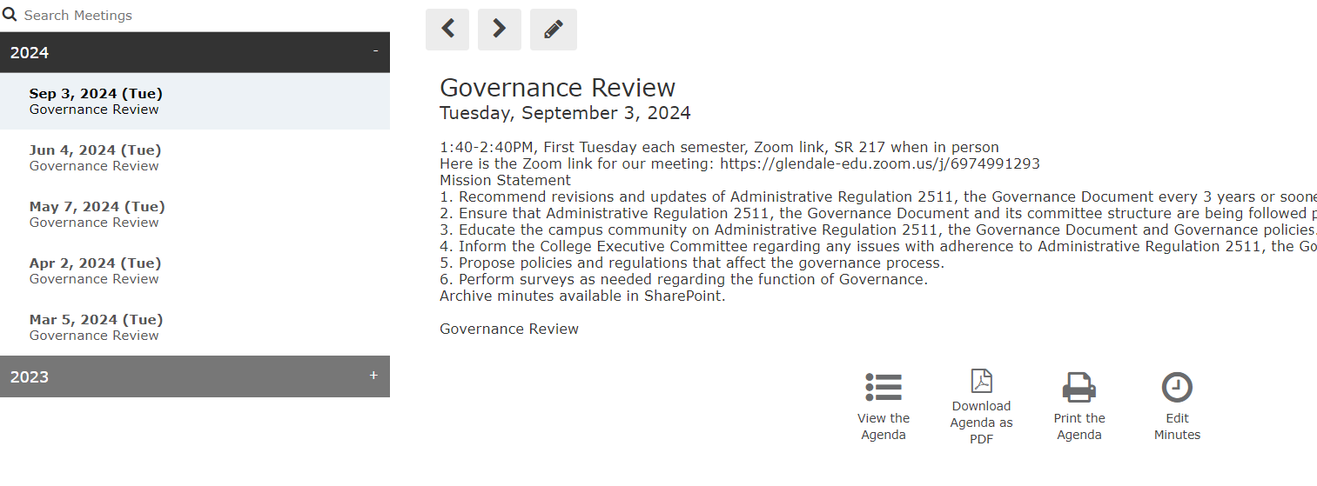

After a meeting, minutes will be made available. Go to Board Docs. The meeting may not be on the “Featured” landing page. To find it go to the menu bar that has the Greek building (the Parthenon), next to it is a pull-down menu of committees.
Select the committee you want to visit.
A list of meetings appears on the left. Select the meeting that you want.
The “View the Minutes” icon is available only when minutes have been produced for that particular meeting.

Be sure to unfeatured your meeting. How to: from the Featured page, right click on your meeting, “unfeature”

