Performing Arts Day
Saturday February 15, 2020

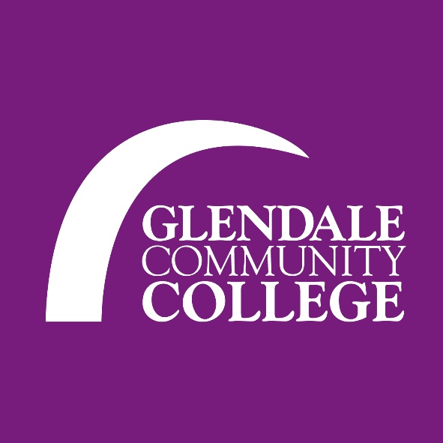

Master Class Entry Form
(to be completed by advisor)

Organization___________________________________________________________Middle/ Senior/ Studio

Address:___________________________________________________ Phone:_____________________________

City/Zip:____________________________________________________Cell:_________________________________

Advisor:_______________________________________ Email: ___________________________________________

Master Class |  |  | # of students
Ballet Fusion Master Class
Victor Robles
Middle Eastern Dance Master Class
Tamra-henna Swan
Lecture: Dance as Protest & Political Activism
Kory Wicks
Jazz Dance Technique Master Class
Chelsea Asman
Salsa Workshop
Ani Hovhannisyan
Lecture: Dance on Film: The Integration of dance & technology
Koryn Wicks
Total # of students attending:

E-mail Form to: vrobles@glendale.edu

Direct questions to: Victor Robles 818-240-1000 ext. 5494/ vrobles@glendale.edu

Advisor listed on entry form will receive all notifications regarding the festival.
If prefer to Mail, send to: Glendale Community College (Attn: Victor Robles)
1500 N. Verdugo Road
Glendale, CA 91208

