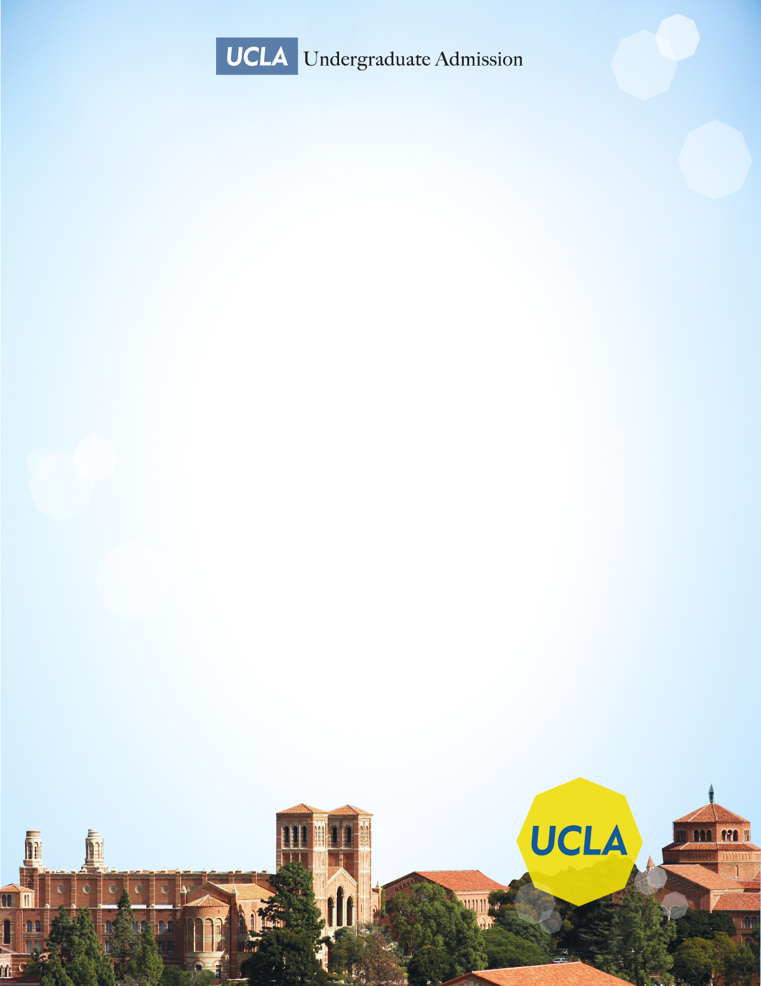
UCLA
TRANSFER ADMISSION WORKSHOP

Come meet your representative from the UCLA Undergraduate Admission office, learn all about admission requirements and major selection, and discover what an application reader looks for in a competitive applicant!

Wednesday, March 27, 2019

12:00PM-1:30PM

Glendale Community College
Transfer Center
Sierra Vista Building 3rd floor

