Additional Notes and Information
TheDescription in the upper left corner will be a brief descrition that will be on the Board Report. Please keep brief, concise, and informational.

Note to Buyer
Click on the second tab under the description, “Source Details” and please be brief. Most of these fields have limited characters. If space is not suffienct please send an email with additional information.

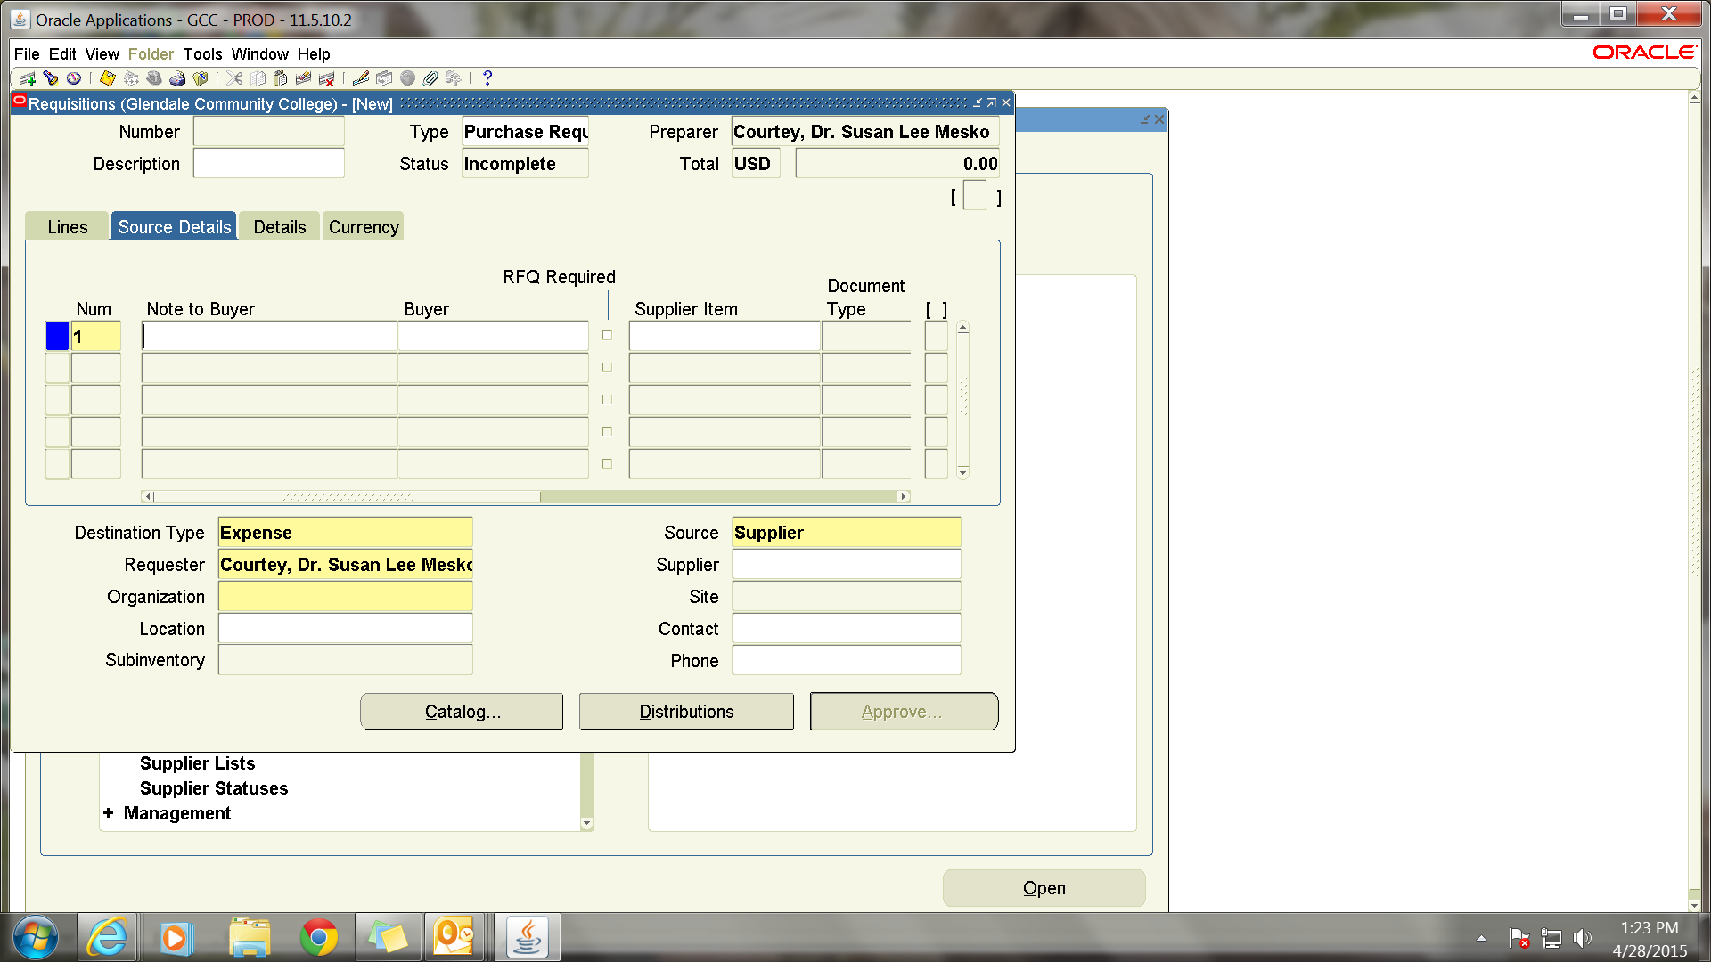

Justifications
Click on third tab “Details” and again, be brief.
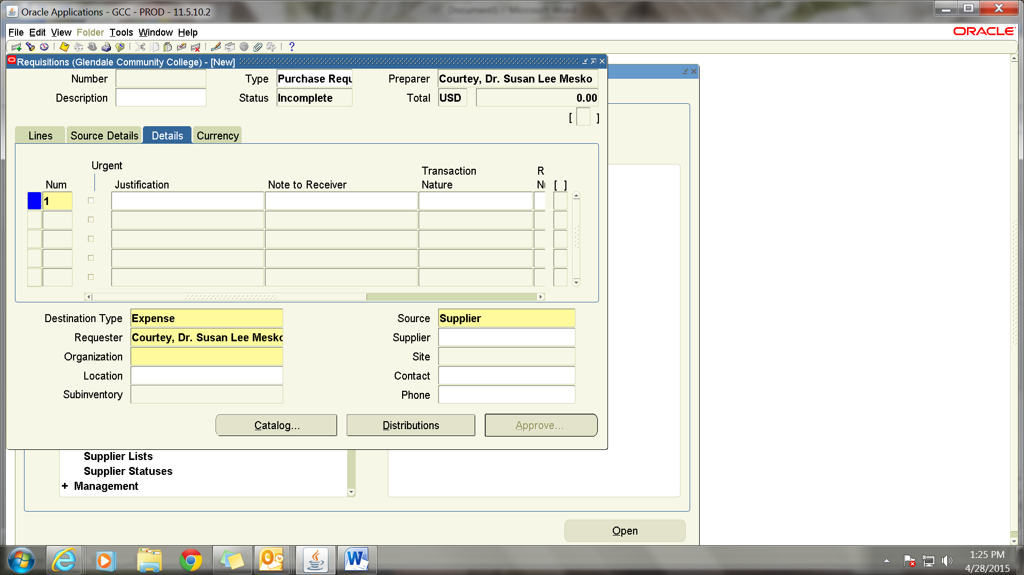

Default Account for Multiple Lines
To use same Account number for all lines click on Tools in the top toolbar. Next click on Preferences and click on the “Charge Account” field. You will get a pop-up to fill in the account number. Click on “Apply” to save the information. Please remember that this will stay your default until you erase or change it. To delete the default account, go back under Preferences, click on the field, and hit space. The number will be erased. Please be sure to click on “Apply” to save the information.
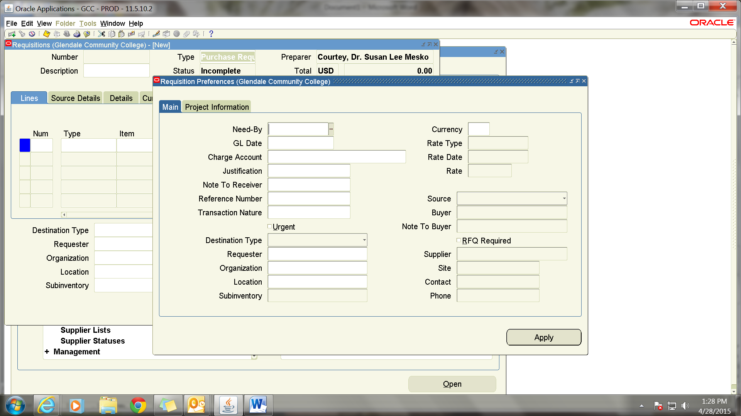

To start the second line click on the second line. To duplicate everything in the prior line click on “Edit” on the top toolbar. You can then go to each field an update only the info that is different to the second line. For example description, price, quantity etc. If you have a default account entered you will not have to go to the distribution page. If you do not, you will have to enter a distribution for every line.
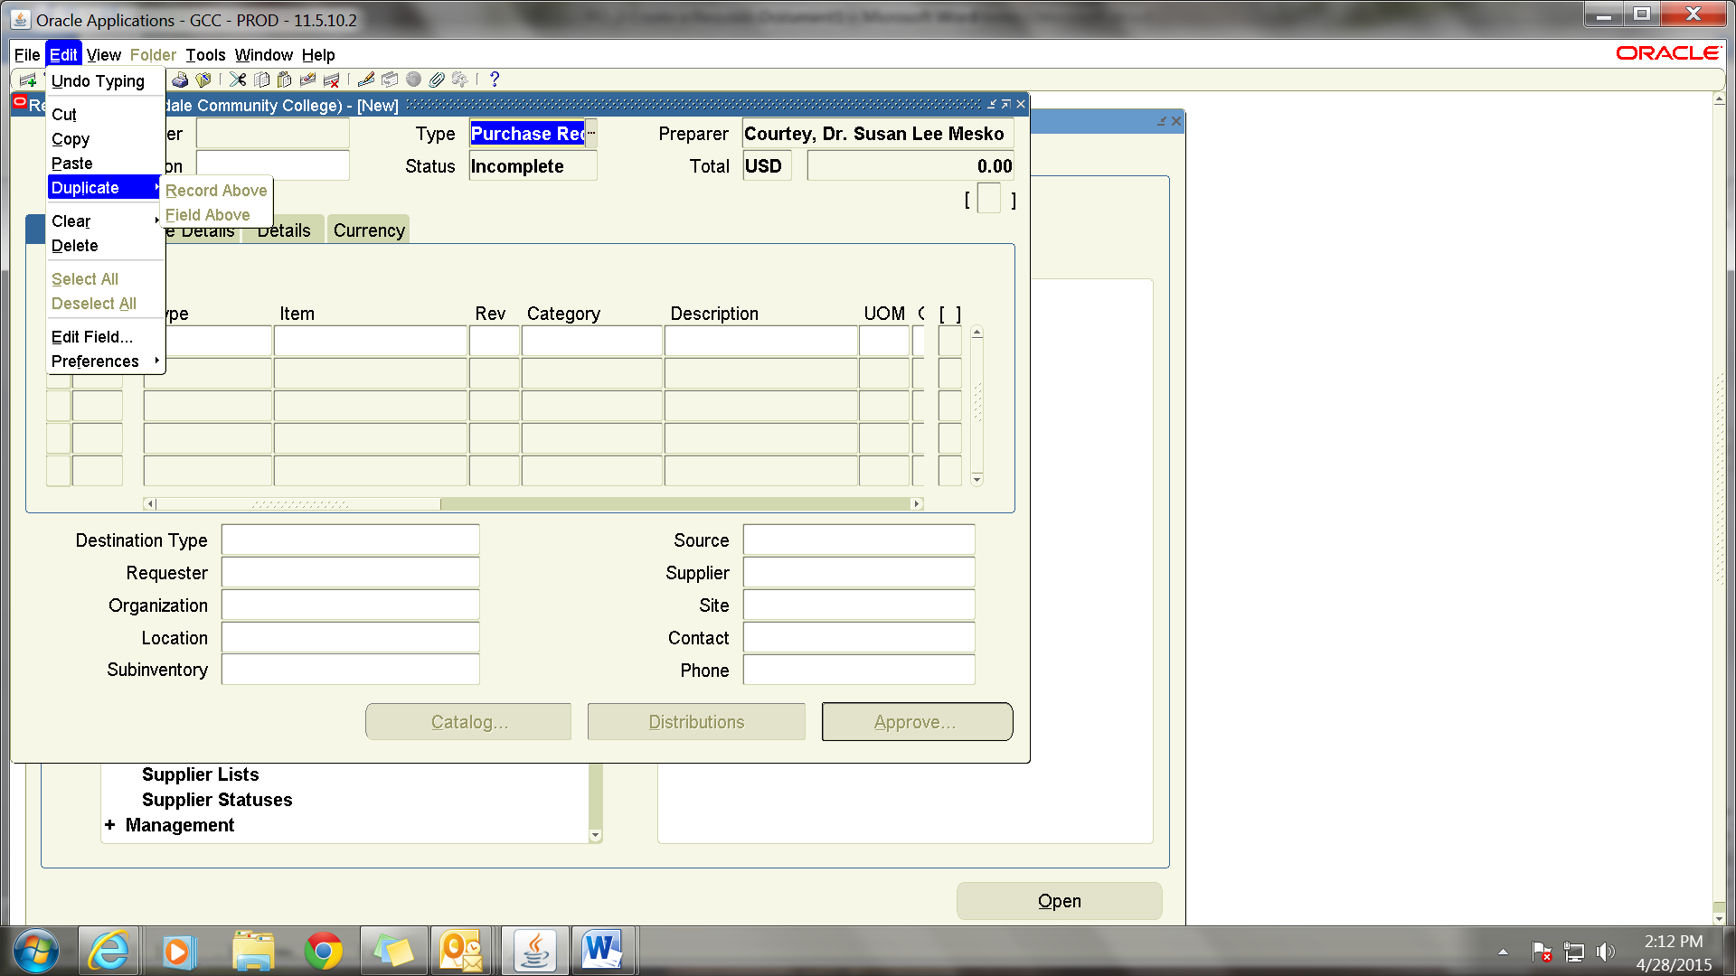

Attachments
Click on the Paperclip on the top toolbar to get a new window. The two yellow field are required.
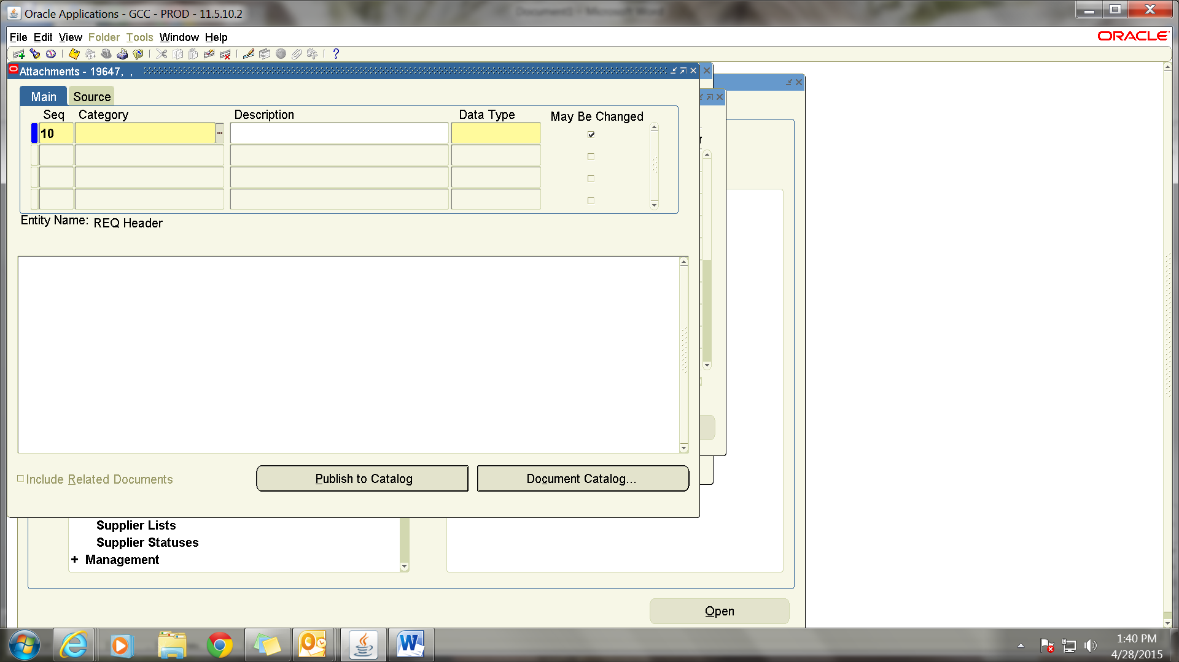

Click on the Category field. Put % to get the list of options or type “Internal to Requisition” and make sure the field fills with the information.
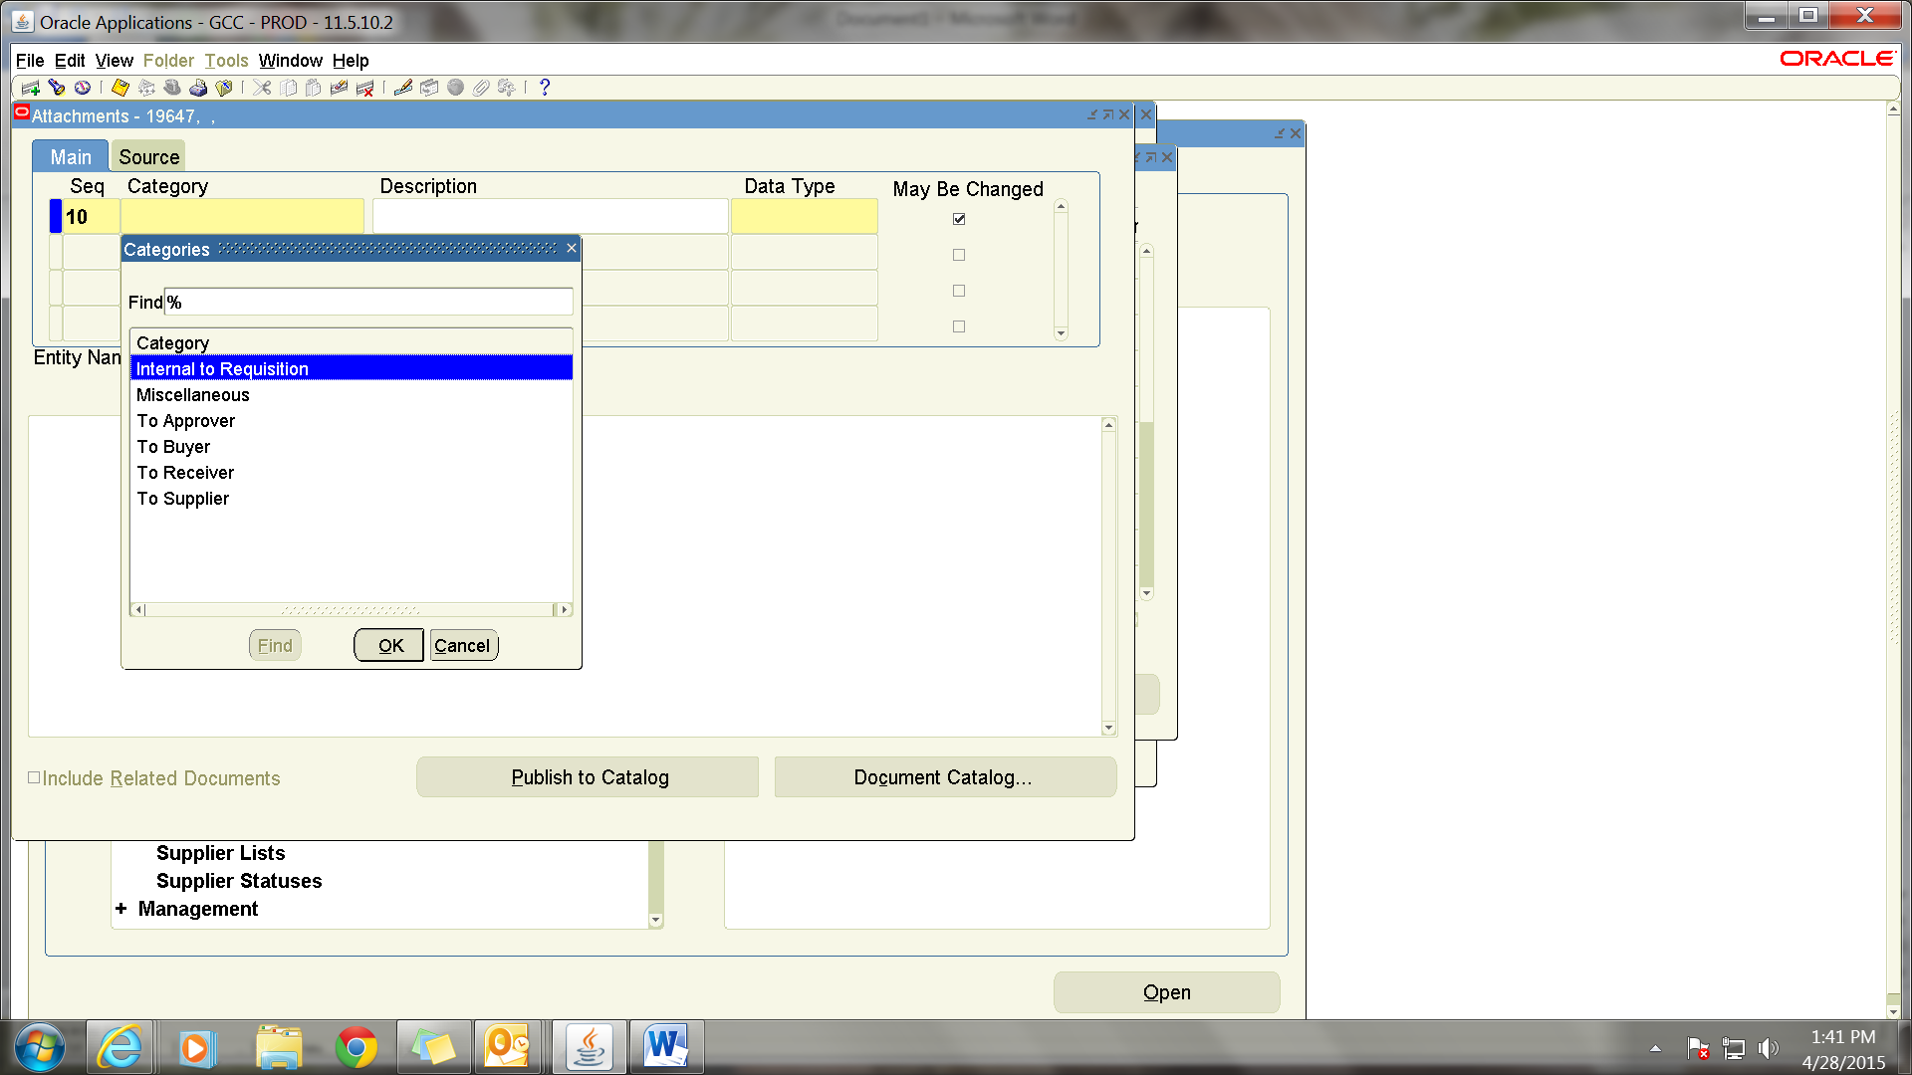

The other required filed is “Data Type.” Click on the three lines to get a drop down, or type “File” to fill this filed. You will be directed to another screen where to browse for the document.
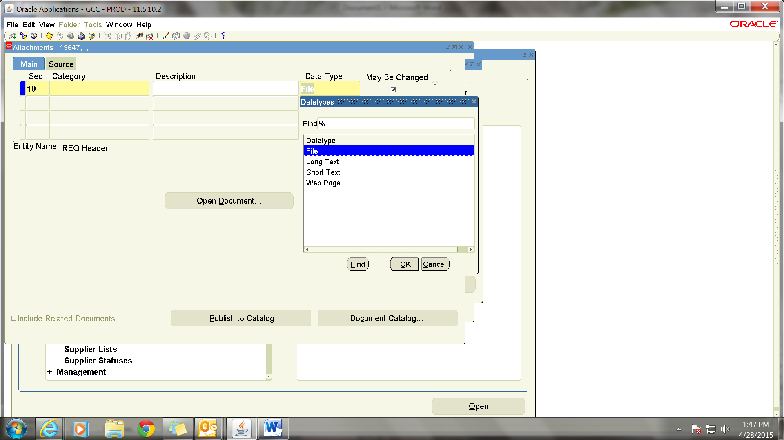
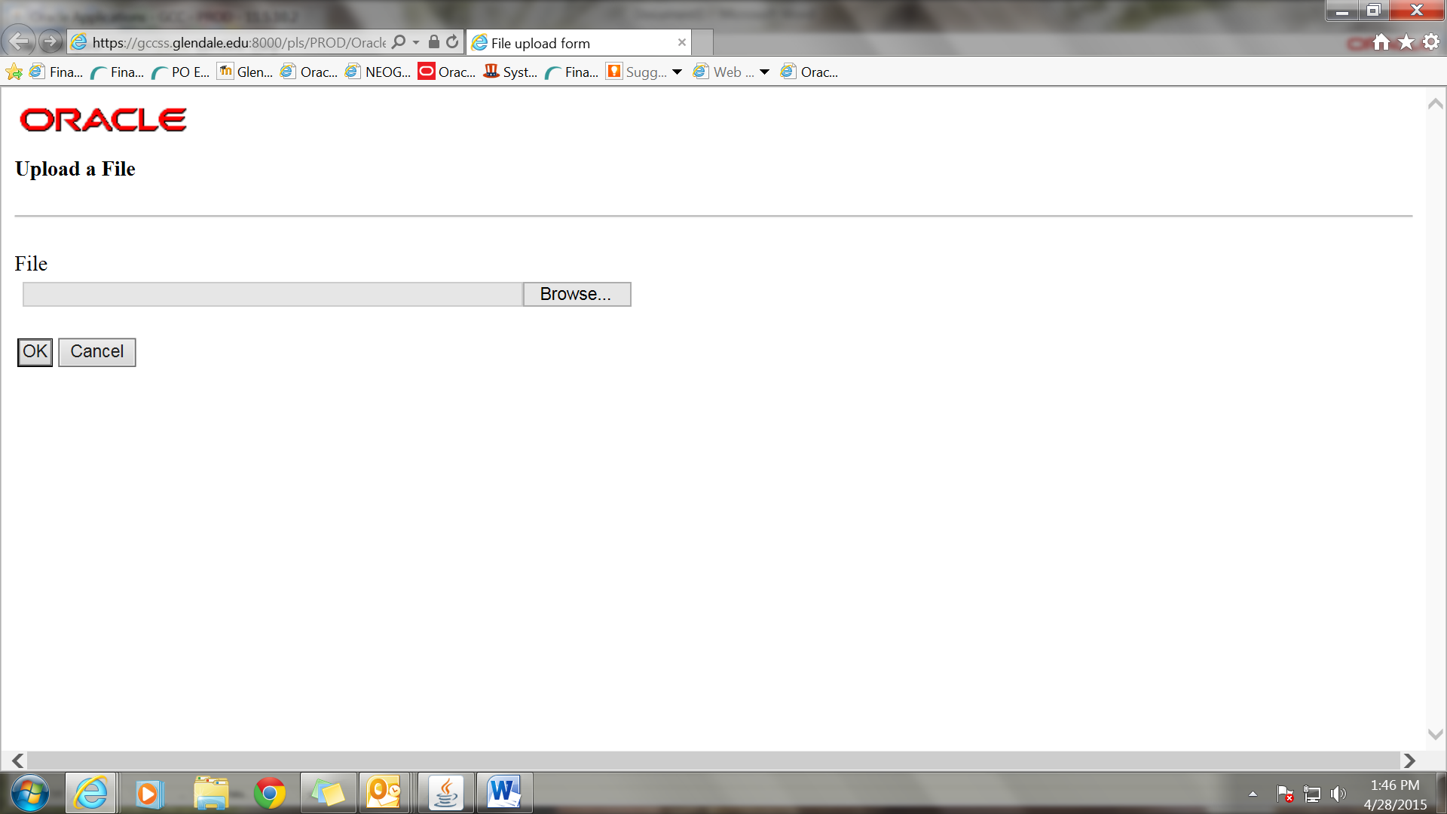

After uploading the document, return to the prior screen and click “Yes”.

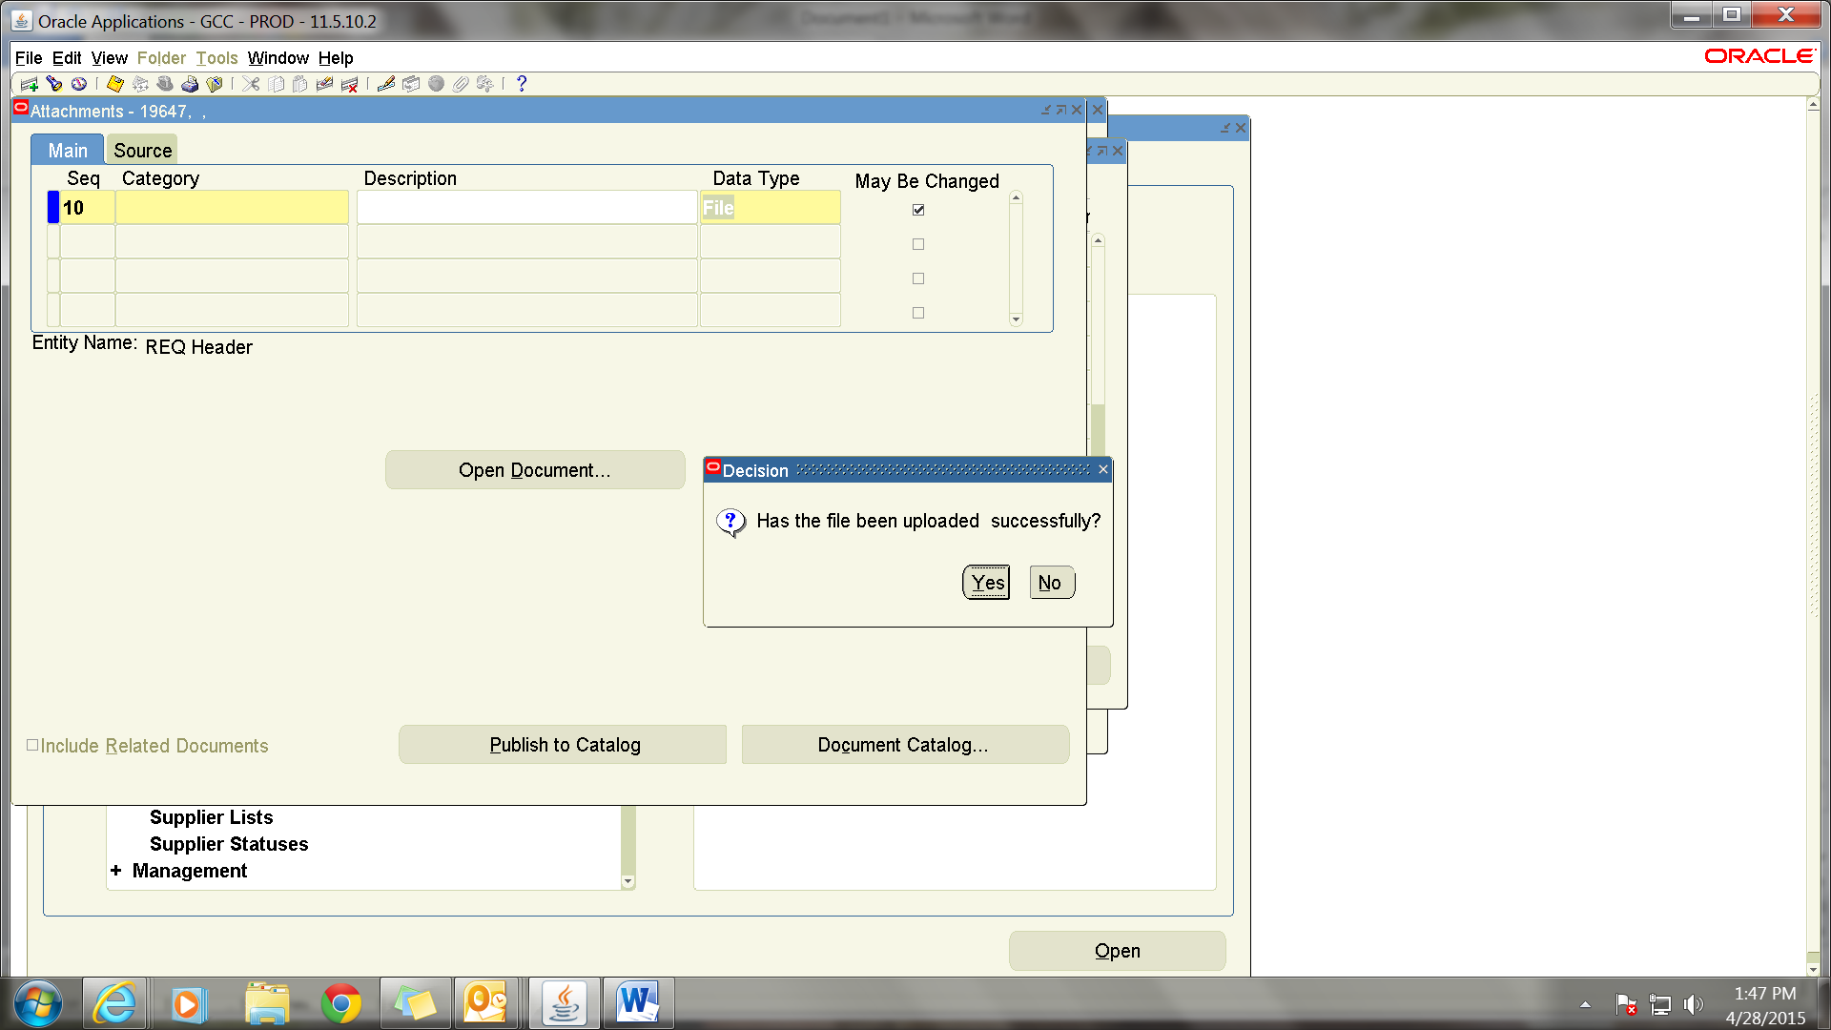

For Splitting Between Multiple Accounts
Enter the requisition as a Service and complete required fields. Click on “Distributions” and click on the “Quantity” field and fill with the dollar amount for the account and enter the account number. Then click on the second line and the remaining amount will fill in the quantity field. If there are only two accounts you can fill in the account number and click on save. If there are more accounts, change the quantity to the dollar amount of the second account and enter it. Then click on the third line, etc.
